A000-US-Mississippian Effigy Pot-Earring Holes and Headdress-Terra cotta-1100-1250 CE

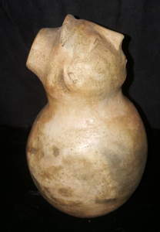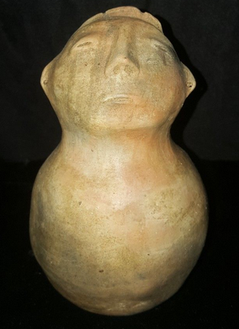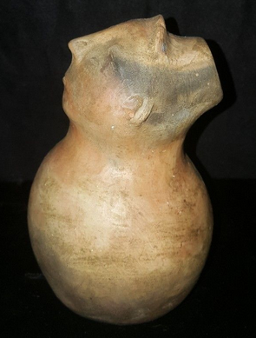

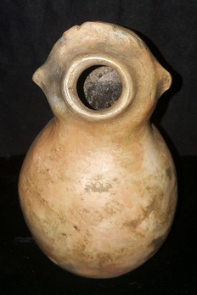 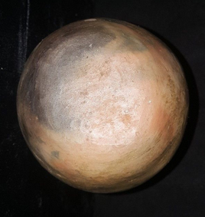

US-Mississippian Effigy Pot-Earring Holes and Headdress-Terra cotta-1100-1250 CE

**Case no.: 12**

**Accession Number:**

**Formal Label:** US-Mississippian Effigy Pot-Earring Holes and Headdress-Terra cotta-1100-1250 CE

**Display Description:**

This is a Southeast Mississippian Effigy vessel that was probably used to contain the Black Drink which was a hallucinogenic liquor. Black Drink was made by the Yuchi, Caddo, Chickasaw, Cherokee, Choctaw, Muscogee and Timuca, peoples of the Southeastern Woodlands in purification ceremonies to remove spiritual and physical contamination and is prepared from a secret formula that varies among groups. However, major ingredients involve the leaves and stems of [*Ilex vomitoria*](https://en.wikipedia.org/wiki/Ilex_vomitoria) and [emetic](https://en.wikipedia.org/wiki/Emetic) herbs to induce vomiting, which is part of the physical process of purification. The removal of spiritual contamination is accomplished with dialogue with a local shaman, whose duty it is to help with the spiritual health of the group. It is important to note that the visage on this effigy pot has closed eyes as if in meditation with his head uplifted as though in prayer to the Great Spirit. This is in fact a shaman who is identified by the earring holes which are a badge of superiority of office and the head piece which looks like a tiara. Therefore, the Black Drink originates from a sacred vessel to assist the participants in their physical and spiritual purification emulating the visage on the pot.

This vessel appears to have been produced at the end of the Neo-Atlantic Altithermal period, before the onset of the Pacific Climatic Period and the dissolution of so many Southeast Mississippian groups from their villages with their central ritual earthen platforms.

**LC Classification: E78. S65**

**Date or Time Horizon:** 1100-1250 CE

**Geographical Area:** Southeastern Woodlands

**Map:**

**GPS coordinates:**

**Cultural Affiliation:** Southeastern Mississippian

**Medium:** terra cotta

**Dimensions:**

**Weight:**

**Condition:**

**Provenance:** Alan Woolworth, St. Paul, MN

**Discussion:**

An engraver named Theodore DeBry made engravings of the drawings that LeMoyne had made of the Timucua ingesting the black Drink in Florida. In 1591, DeBry published a book with the engravings and LeMoyne’s description of his trip to Florida.



A 16th-century engraving by Jacques le Moyne of Timucua people consuming the Black Drink and its effect on vomiting (de Bry et al. 1592).

**References:**

de Bry, Theodor; Nicolas Barré; Hans Staden; Jean de Léry. 1592. ***Americae tertia pars memorabilẽ provinciæ Brasiliæ historiam continẽs, Germanico primùm sermone scriptam à Ioãne Stadio, nunc autem Latinitate donatam à Teucrio Annæo Priuato Colchanthe [i.e. J.A. Lonicer] Addita est narratio profectionis Ioannis Lerij in eamdem provinciam, quã ille intio Gallicè conscripsit, postea verò Latinam fecit. His accessit descriptio morum & ferocitatis incolarum illius regiones, atque colloquium ipsorum idiomate conscriptum.*** [Francofvrti ad Moenvm], [Impressum apvd I. Wechelvm, impensis T. de Bry] venales reperiũtur in officina T. de Bry.

Hudson,, Charles, M. 1979. Black Drink: A Native American Tea. Macon:University of Georgia Press.